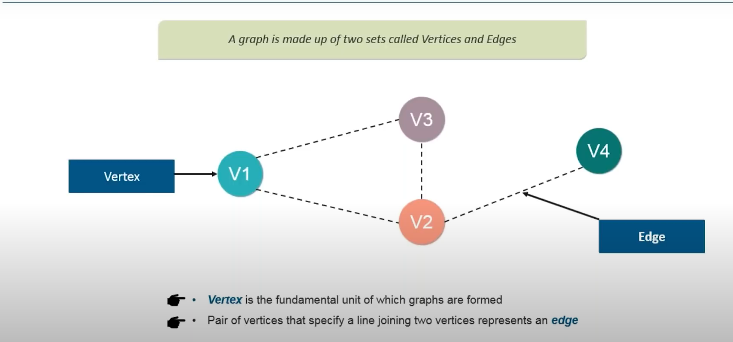

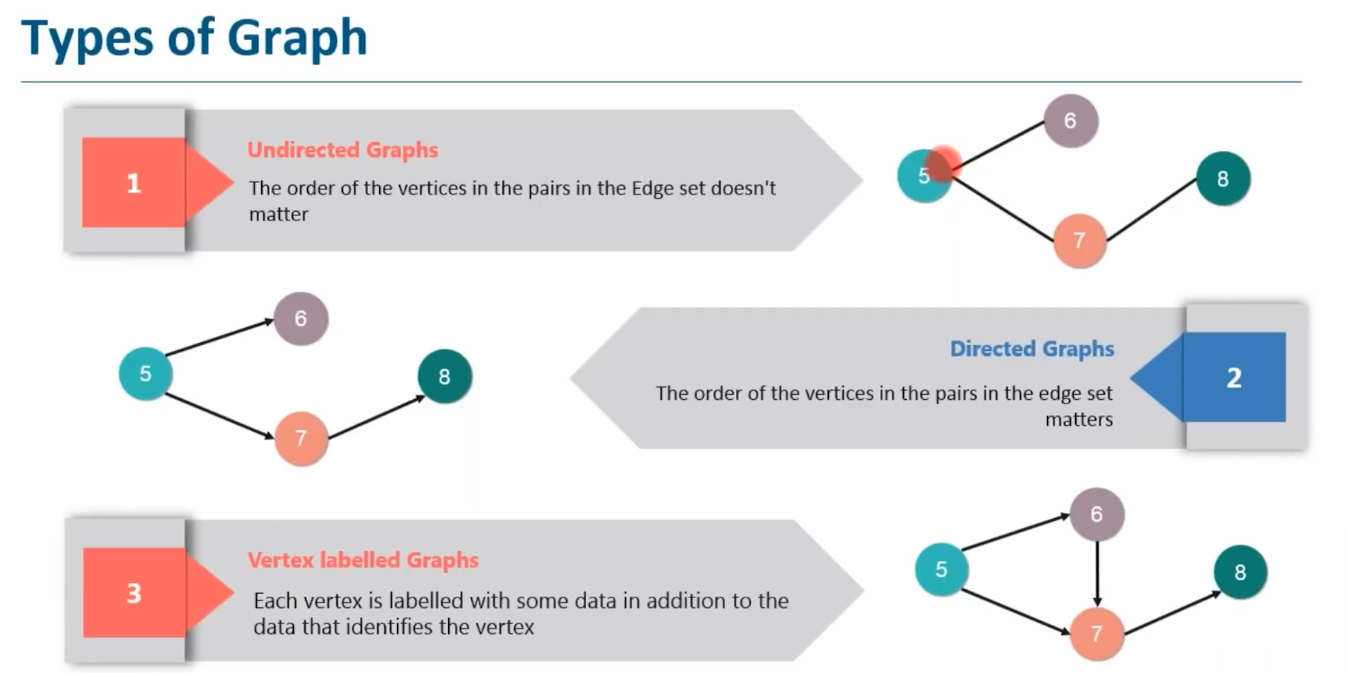

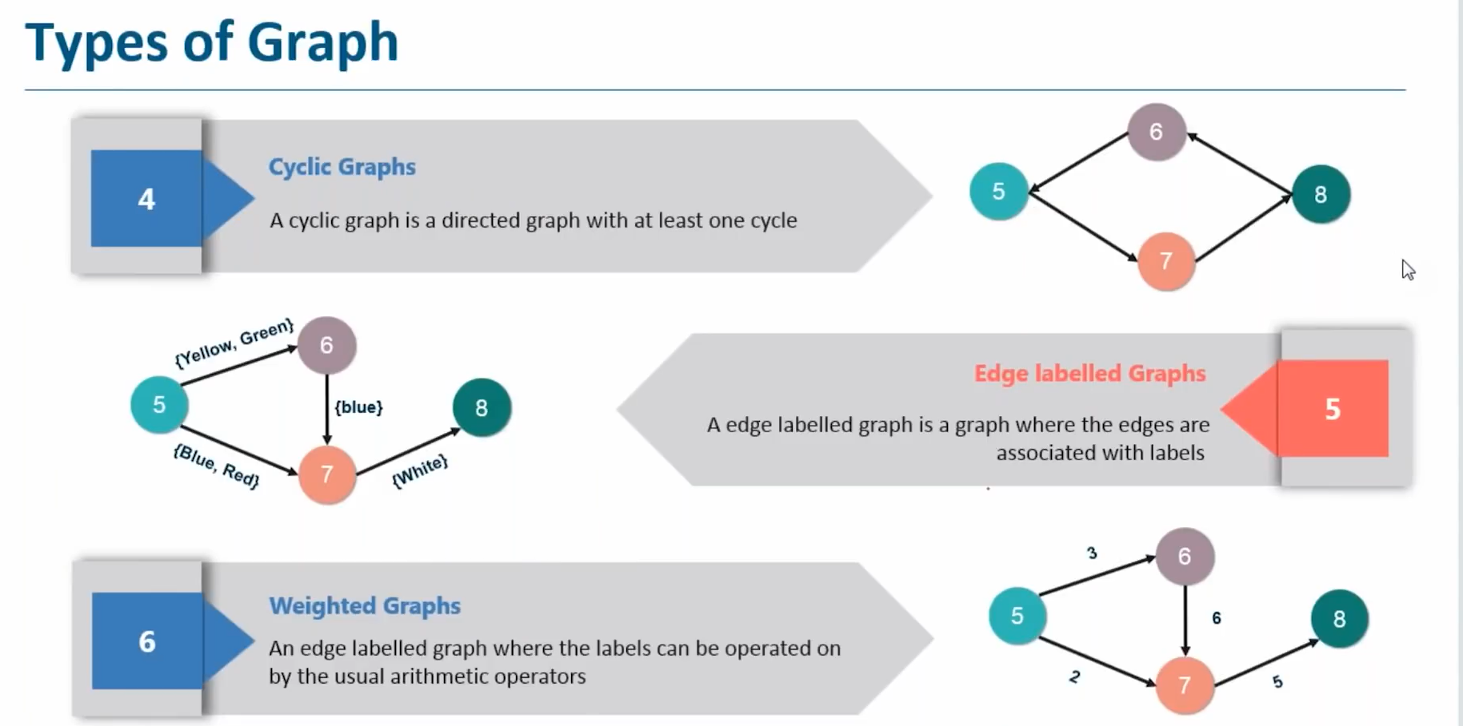

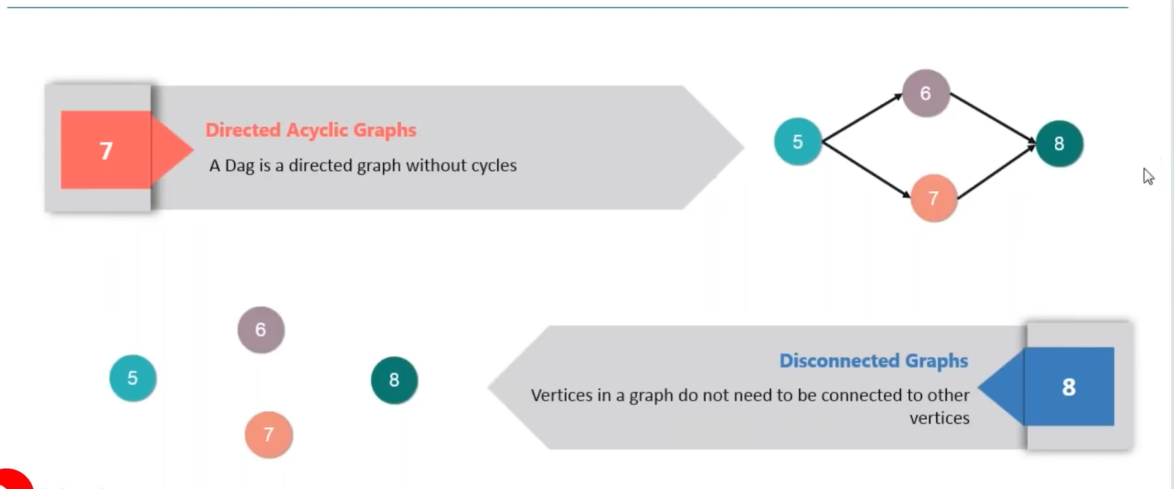

**GRAPH X**

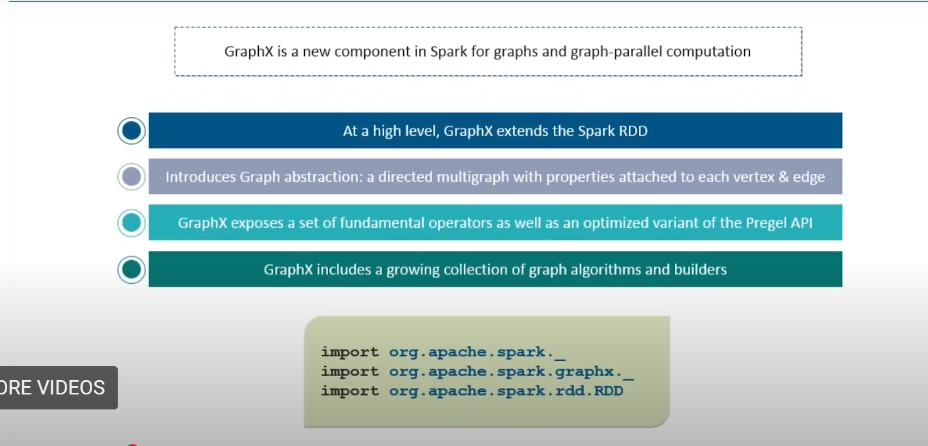

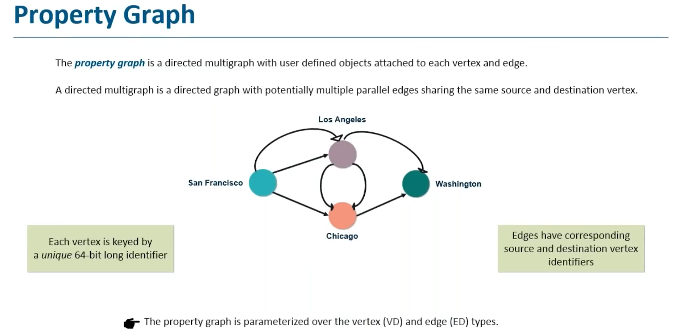

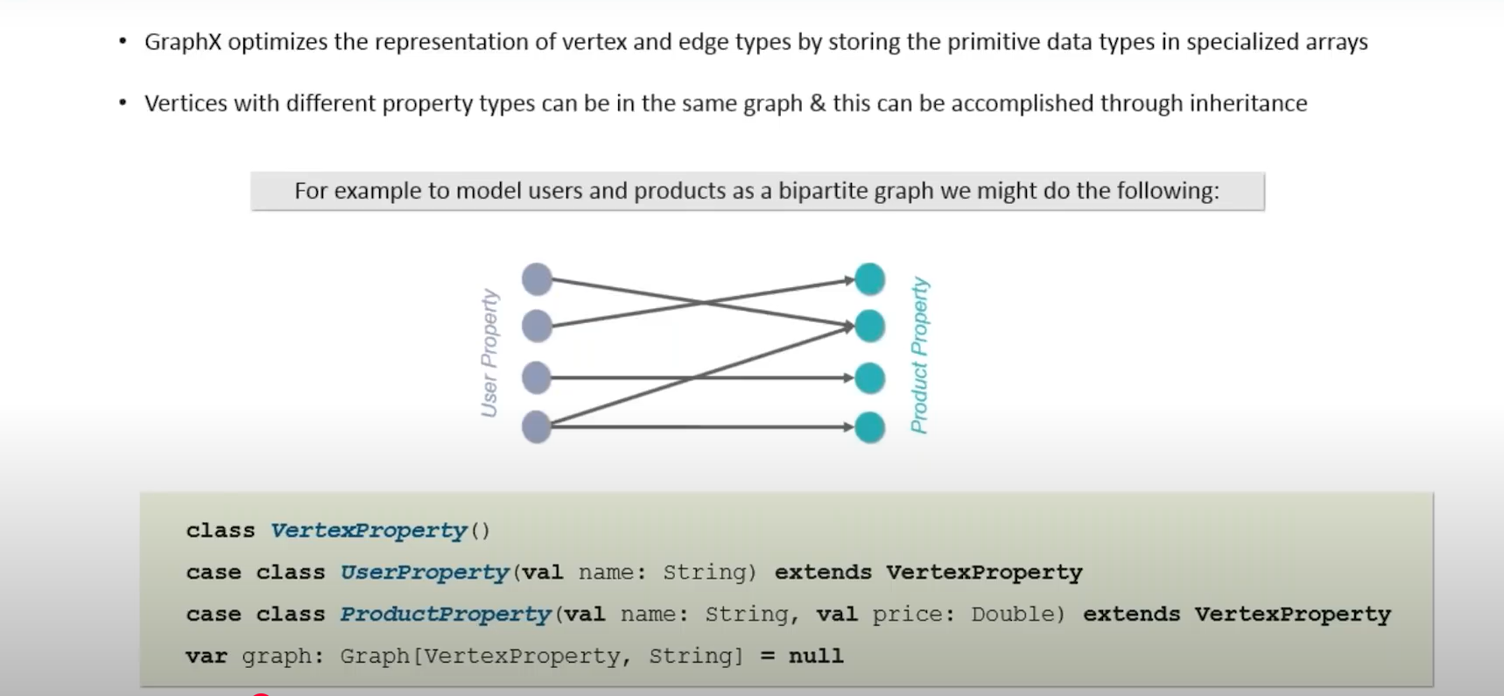

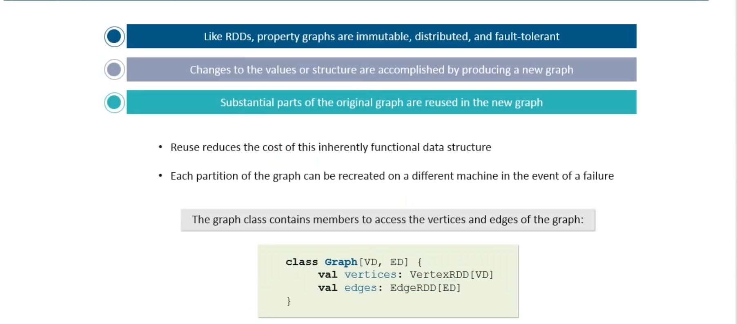

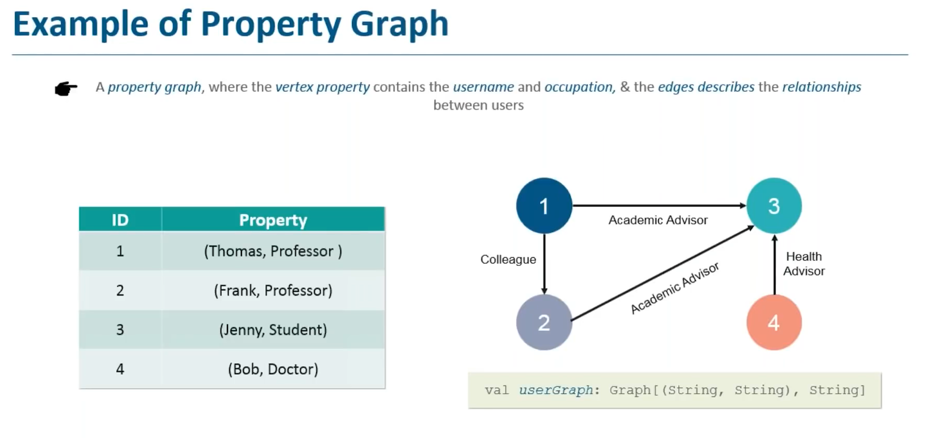

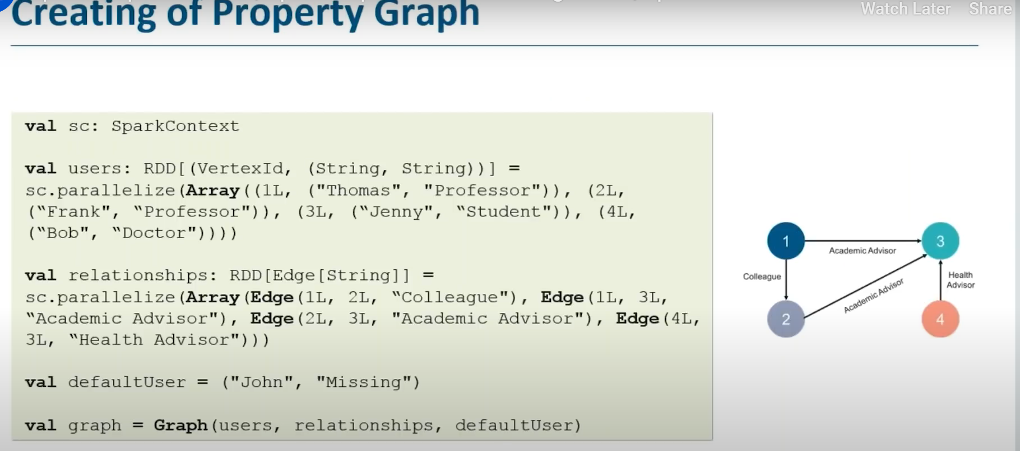

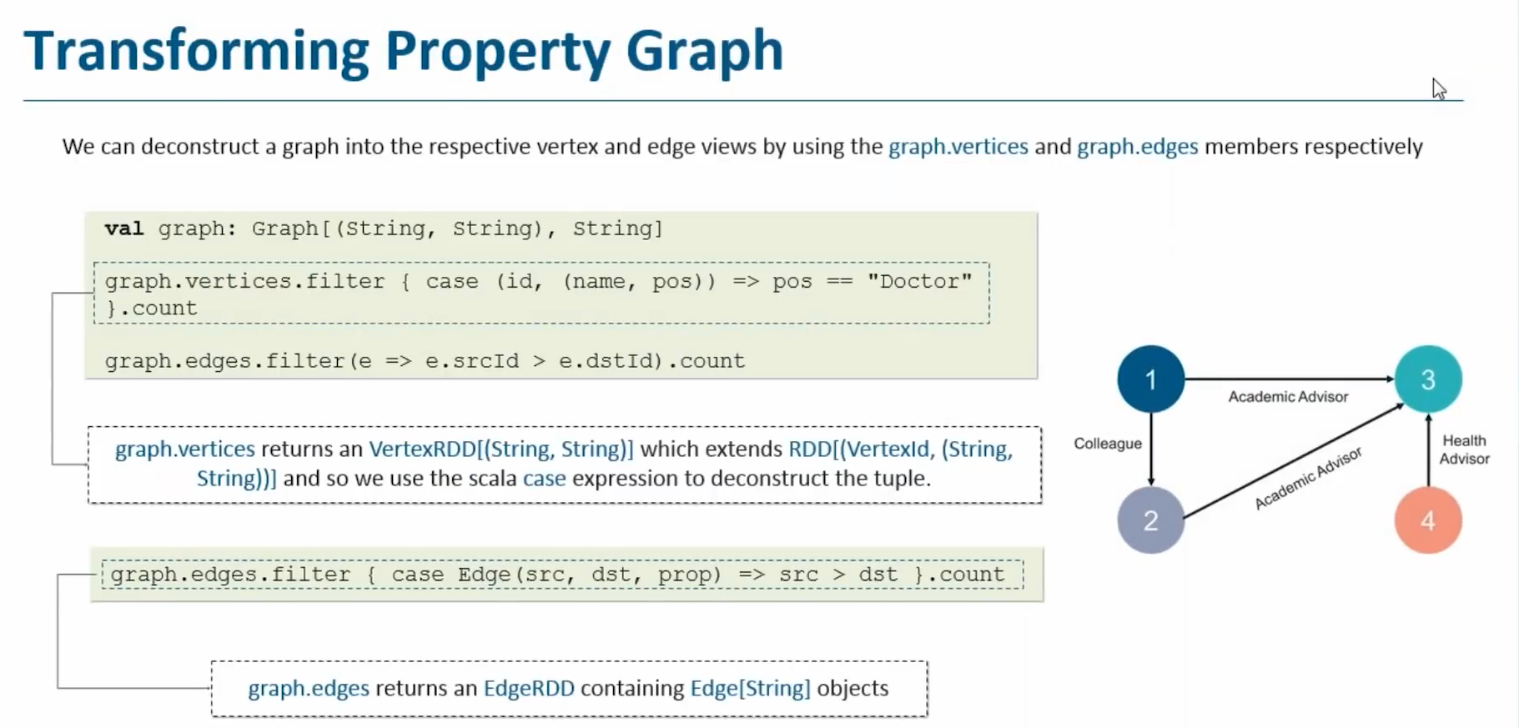

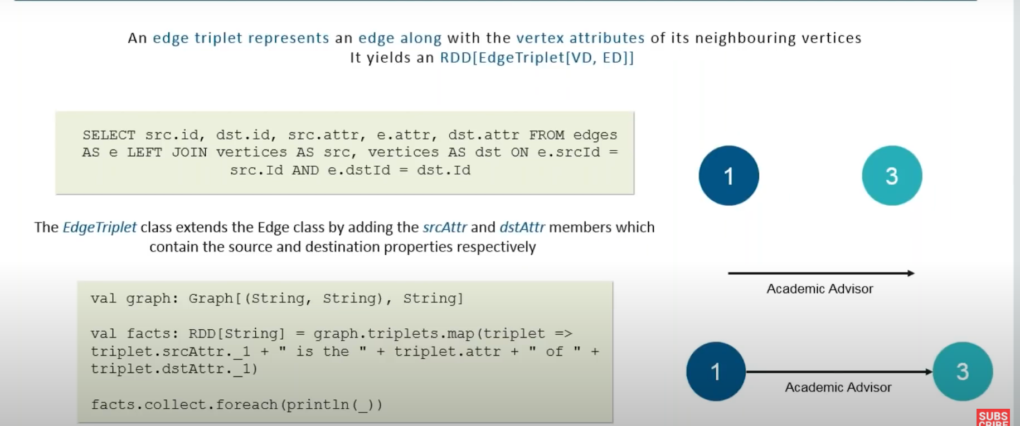

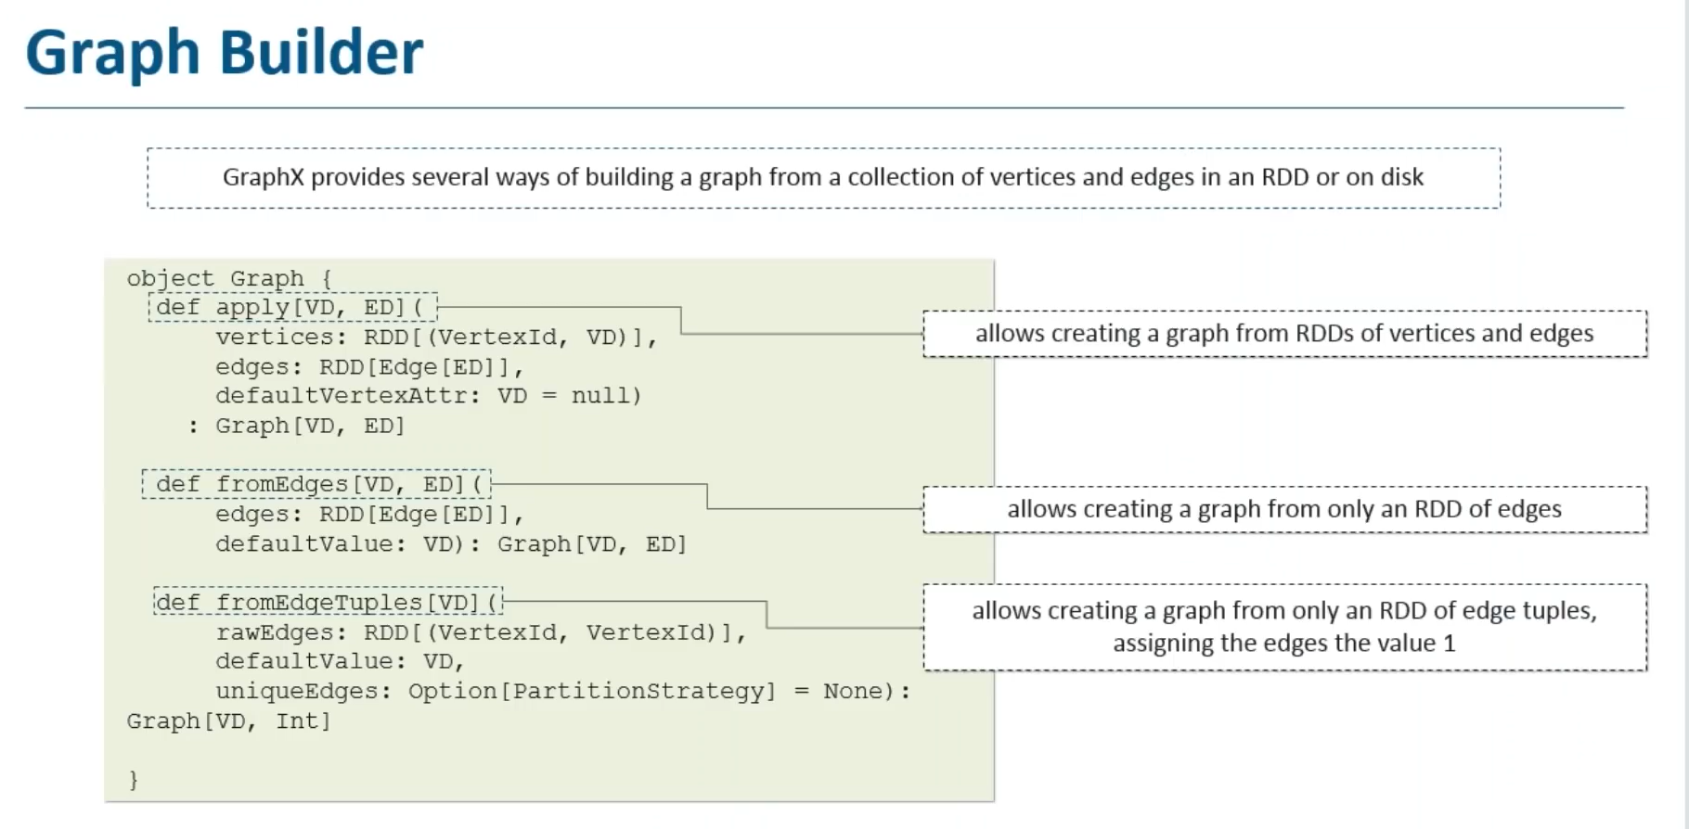

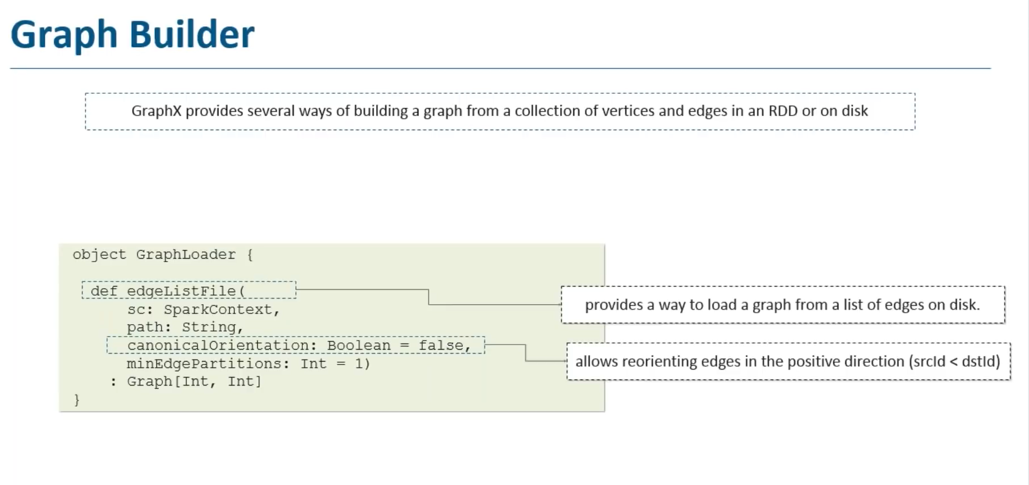

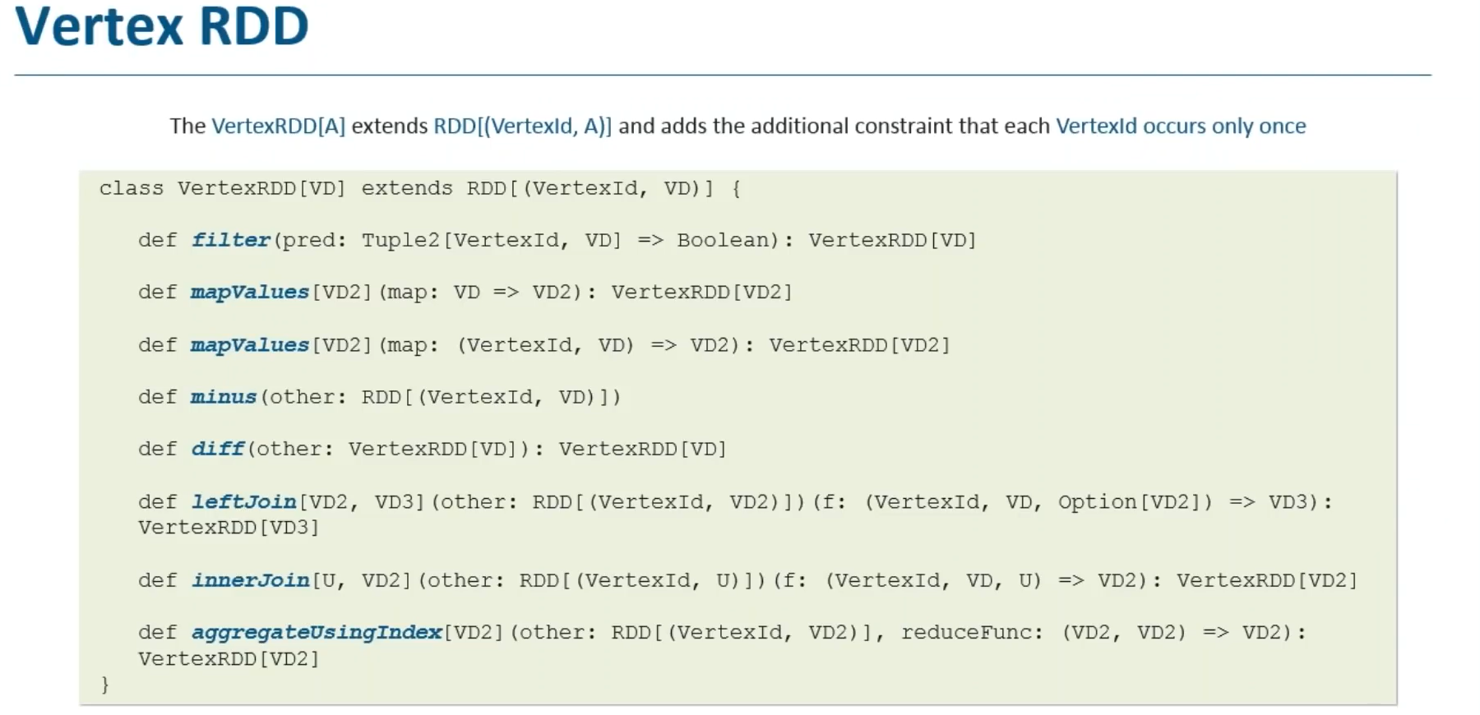

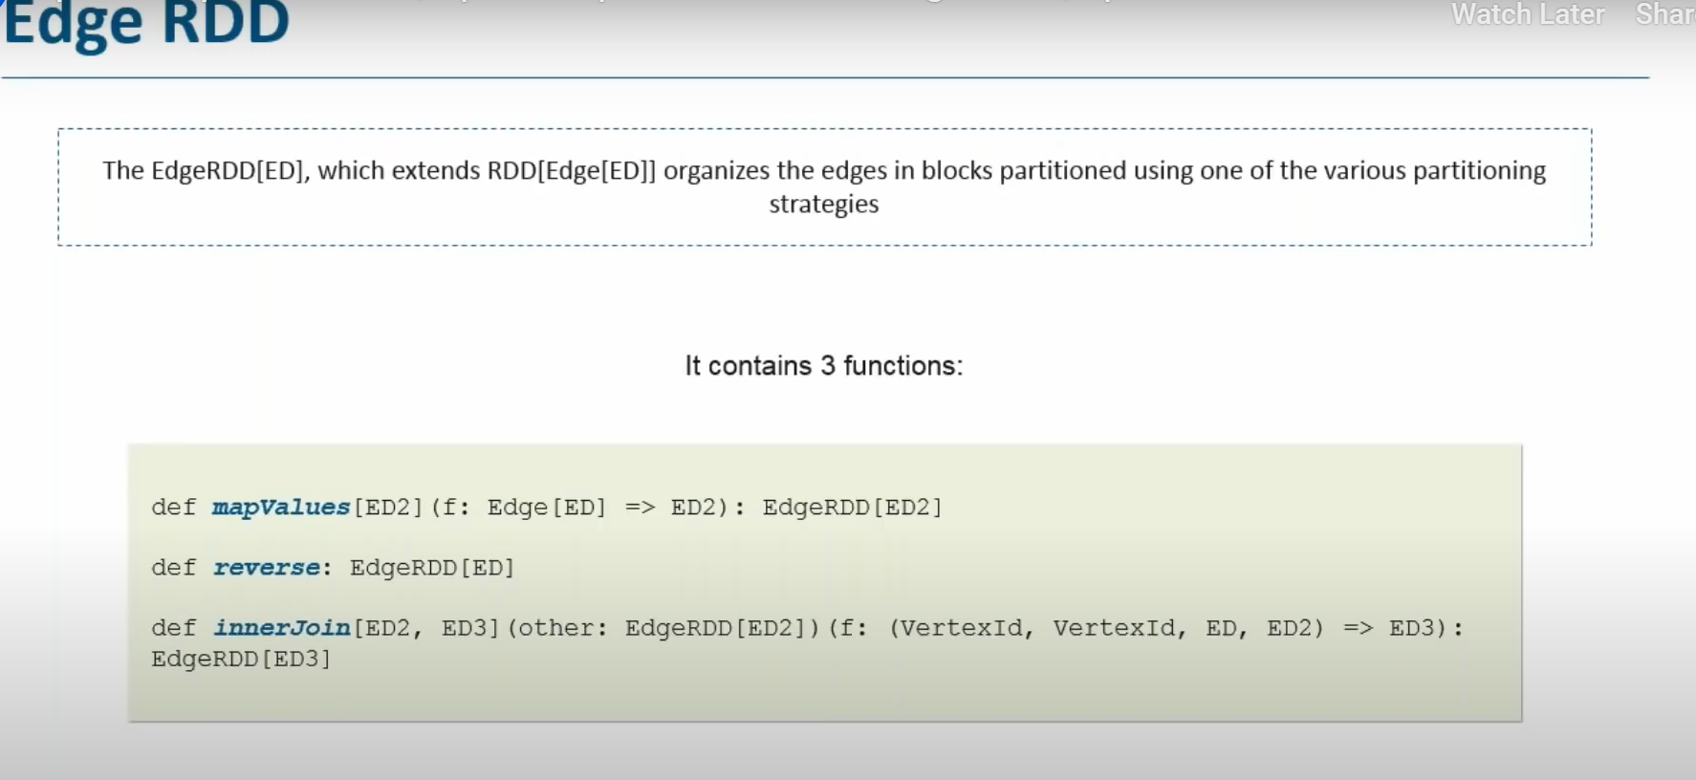

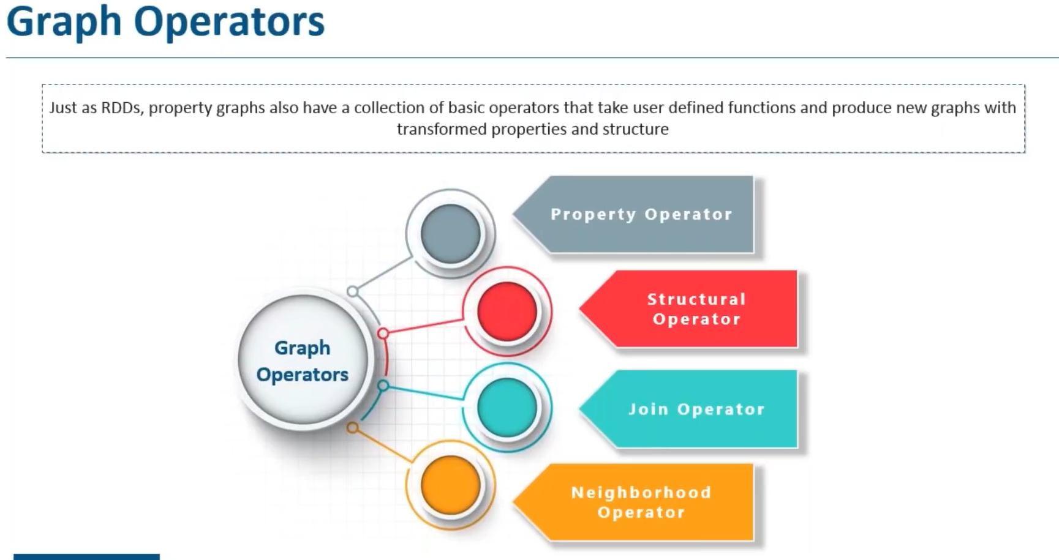

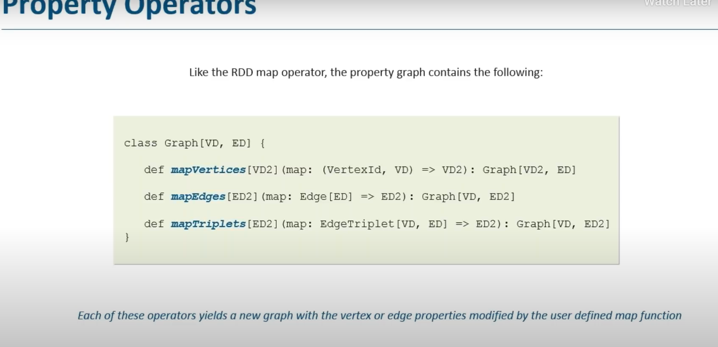

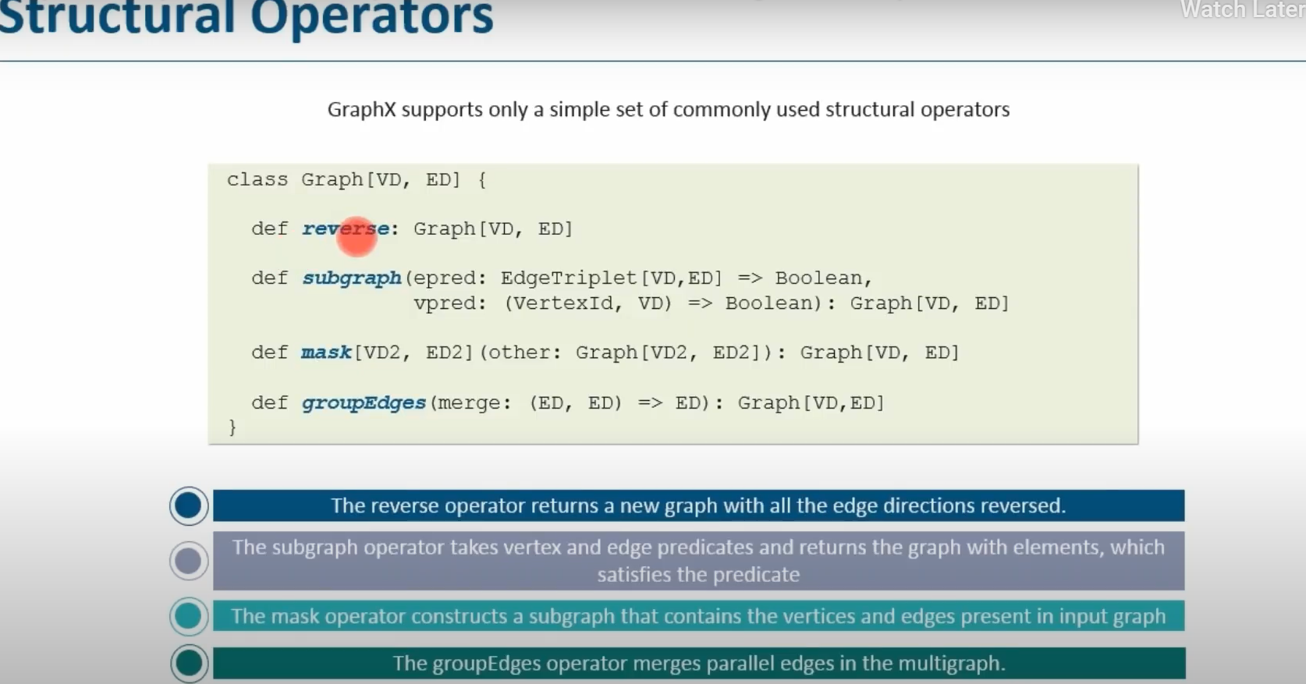

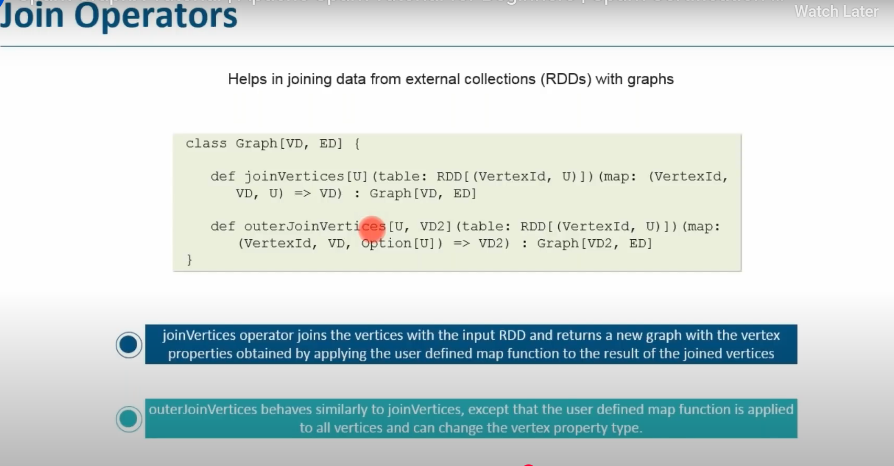

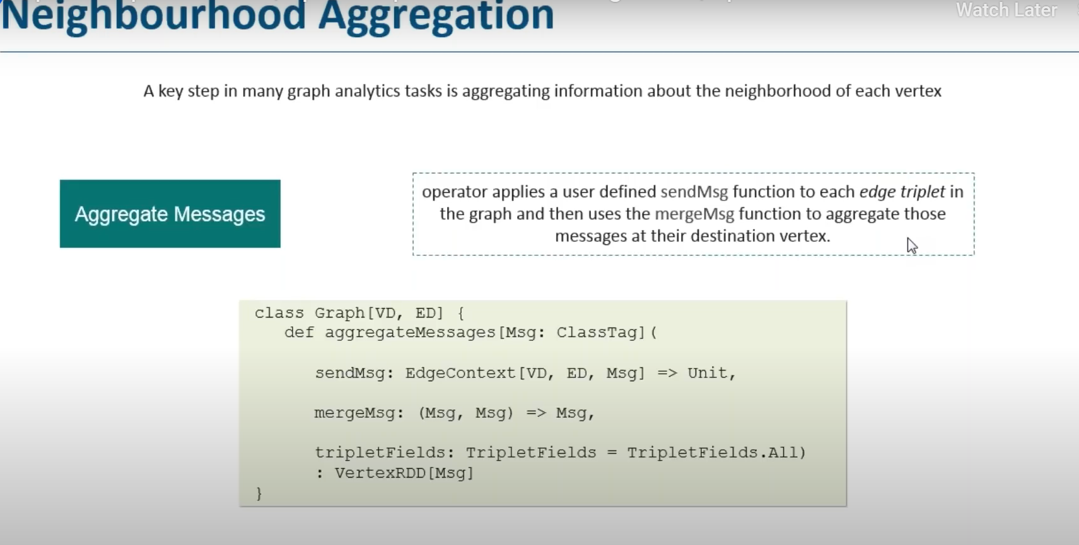

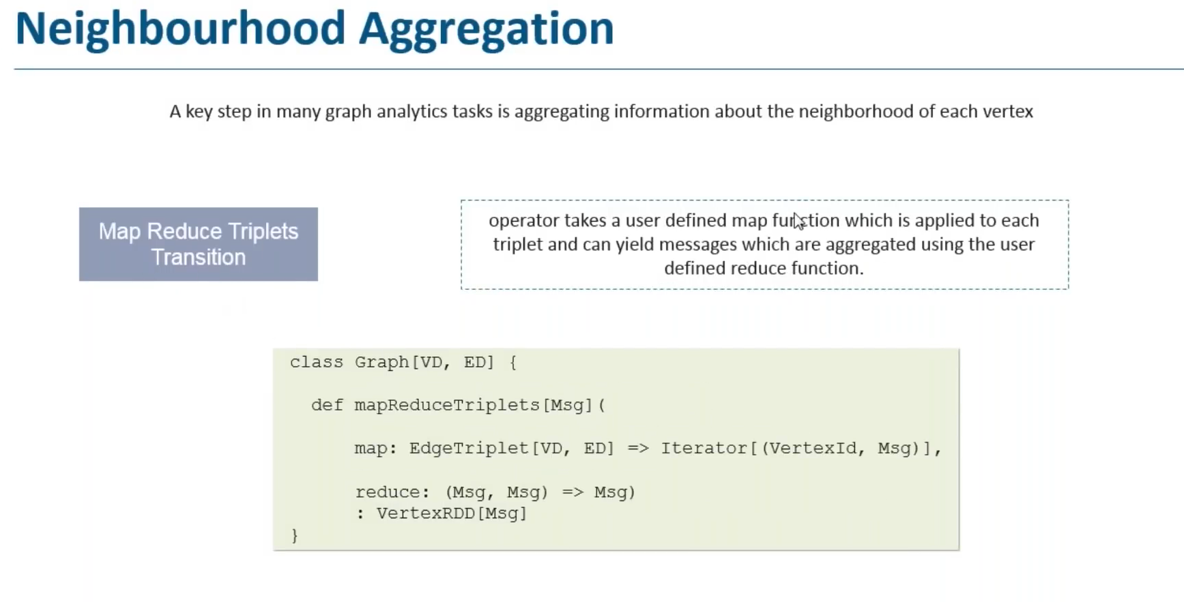

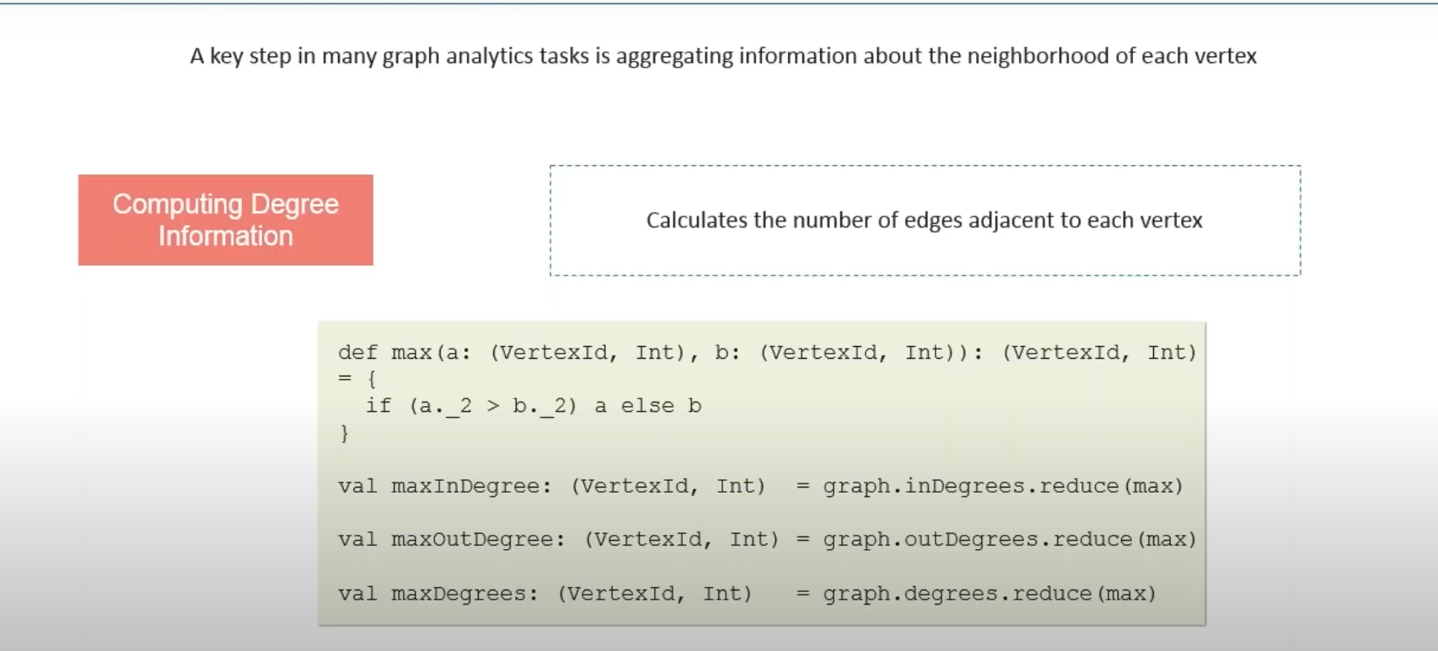

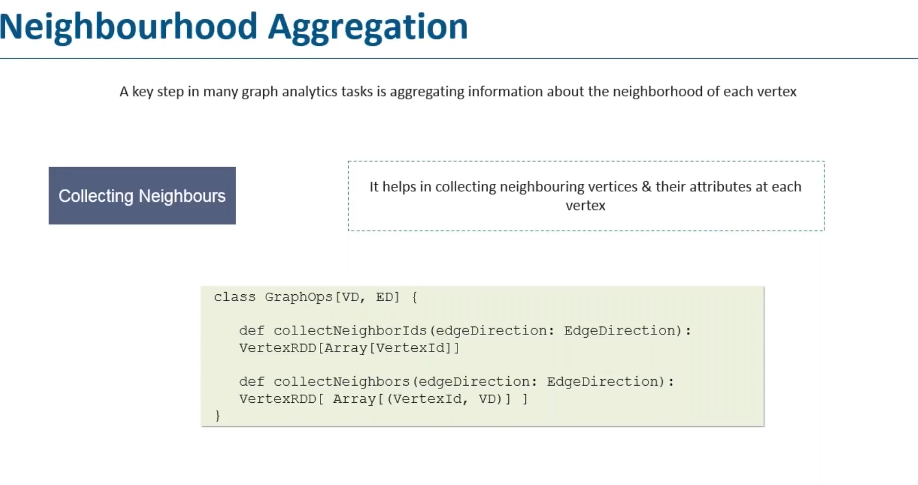

**Broadcast Variables**

**Purpose:**

* Used to share **read-only data** efficiently with all worker nodes in a Spark cluster.
* Instead of sending the same large dataset with every task, Spark sends it **once** to each executor.

**Why?**  
Without broadcasting, if you have a large lookup table used in many tasks, Spark would **duplicate** it in each task → wastes memory and bandwidth.  
Broadcast variables ensure **only one copy per executor**.

**Example in Scala:**

import org.apache.spark.sql.SparkSession

val spark = SparkSession.builder()

.appName("BroadcastExample")

.master("local[*]")

.getOrCreate()

val sc = spark.sparkContext

// A small lookup map

val lookupMap = Map(1 -> "Apple", 2 -> "Banana", 3 -> "Cherry")

// Broadcast it

val broadcastVar = sc.broadcast(lookupMap)

val data = sc.parallelize(Seq(1, 2, 3, 2, 1))

val result = data.map(id => broadcastVar.value(id))

result.collect().foreach(println)

**Key Points:**

* **Immutable** — read-only data
* Lives in **executor memory**
* Accessed via .value
* Ideal for **lookup tables, constants, configurations**

**Accumulators**

**Purpose:**

* Variables that are used to **aggregate** information across Spark workers.
* Workers can **only add** to them — no read access during execution.

**Why?**  
They’re great for **counters, sums, debugging metrics** in distributed processing.

**Example in Scala:**

val acc = sc.longAccumulator("ErrorCounter")

val data = sc.parallelize(Seq("ok", "error", "ok", "error", "error"))

data.foreach { word =>

if (word == "error") acc.add(1)

}

println(s"Total errors: ${acc.value}")

**When to Use**

✅ **Broadcast** → Large static data reused in transformations (e.g., reference dataset for joins).  
✅ **Accumulator** → Metrics collection during execution (e.g., record counts, error tracking).

**What is a Partitioner in Spark?**

* **Partitioner** decides **how RDD elements are distributed** across partitions based on their key.
* In key-value RDDs (like PairRDD[String, Int]), Spark needs to know **which key goes to which partition**.
* Default:
  + HashPartitioner → uses hashCode(key) % numPartitions
  + RangePartitioner → splits based on sorted key ranges

**Why Custom Partitioners?**

Default partitioning isn’t always optimal.  
We use **Custom Partitioners** when:

* You want **related keys** to go to the **same partition** (e.g., all transactions from a customer ID)
* You have **skewed data** and want to control partition sizes
* You have **domain-specific grouping rules** (e.g., partition by country code)

**How to Create a Custom Partitioner**

* Extend org.apache.spark.Partitioner
* Implement:
  1. numPartitions → returns the total number of partitions
  2. getPartition(key: Any): Int → returns the partition index for a given key (0 to numPartitions - 1)

import org.apache.spark.sql.SparkSession

import org.apache.spark.Partitioner

// Custom Partitioner

class FirstLetterPartitioner(partitions: Int) extends Partitioner {

require(partitions > 0, "Number of partitions must be positive")

override def numPartitions: Int = partitions

override def getPartition(key: Any): Int = {

key match {

case null => 0

case s: String if s.nonEmpty =>

(s.toLowerCase.charAt(0) - 'a') % numPartitions

case _ => 0

}

}

override def equals(other: Any): Boolean = other match {

case p: FirstLetterPartitioner => p.numPartitions == numPartitions

case _ => false

}

}

object CustomPartitionerExample {

def main(args: Array[String]): Unit = {

val spark = SparkSession.builder()

.appName("CustomPartitionerExample")

.master("local[*]")

.getOrCreate()

val sc = spark.sparkContext

val data = sc.parallelize(Seq(

("Alice", 1), ("Bob", 2), ("Charlie", 3),

("David", 4), ("Eve", 5), ("Frank", 6)

))

val partitionedRDD = data.partitionBy(new FirstLetterPartitioner(3))

partitionedRDD.mapPartitionsWithIndex((index, it) =>

it.map(x => s"Partition: $index => $x")

).collect().foreach(println)

spark.stop()

}

}

**Why Memory Management Matters in Spark**

* Spark runs **in-memory computations** for speed.
* Poor memory handling can cause **GC overhead, OOM errors, and slow jobs**.
* Spark divides available executor memory into different regions for:
  + **Execution** (shuffles, joins, aggregations)
  + **Storage** (cached RDDs, broadcast variables)
  + **User Data & Overhead**

Debugging Spark applications

**1. Performance Optimization**

Performance optimization in Spark is about making jobs run faster, consume fewer resources, and handle larger datasets efficiently. It involves:

* Reducing **data shuffling** between nodes.
* Avoiding unnecessary computation through **lazy evaluation** and **predicate pushdown**.
* Optimizing **joins** using broadcast joins or partitioning.
* Using **efficient file formats** like Parquet/ORC instead of CSV.
* Applying **parallelism tuning** to balance workload across executors.

import org.apache.spark.sql.SparkSession

object PerformanceOptimization {

def main(args: Array[String]): Unit = {

val spark = SparkSession.builder()

.appName("PerformanceOptimization")

.getOrCreate()

// Read Parquet (columnar & optimized)

val df = spark.read.parquet("hdfs://path/to/data.parquet")

// Filter early (predicate pushdown)

val filteredDF = df.filter("status = 'ACTIVE'")

// Repartition based on join key to reduce shuffle

val otherDF = spark.read.parquet("hdfs://path/to/other.parquet")

val joinedDF = filteredDF.repartition($"user_id")

.join(otherDF, Seq("user_id"))

joinedDF.write.mode("overwrite").parquet("hdfs://path/to/output")

spark.stop()

}

}

**2. Spark Configuration**

Spark configuration controls how jobs are executed. Key settings include:

* **spark.executor.memory** – Memory per executor process.
* **spark.executor.cores** – Number of cores per executor.
* **spark.driver.memory** – Memory for the driver program.
* **spark.sql.shuffle.partitions** – Number of partitions for shuffles (default 200, often needs tuning).
* **spark.dynamicAllocation.enabled** – Adjusts executor allocation automatically.
* Configs can be set:
  + In spark-submit command.
  + In spark-defaults.conf.
  + Programmatically via spark.conf.set().

import org.apache.spark.sql.SparkSession

object SparkConfiguration {

def main(args: Array[String]): Unit = {

val spark = SparkSession.builder()

.appName("SparkConfigExample")

.config("spark.executor.memory", "4g")

.config("spark.executor.cores", "2")

.config("spark.sql.shuffle.partitions", "100")

.getOrCreate()

val df = spark.read.parquet("hdfs://path/to/data.parquet")

df.show()

spark.stop()

}

}

**3. Caching Strategies**

Caching stores intermediate results in memory (or disk) to avoid recomputation:

* **cache()** – Stores RDD/DataFrame in memory (default).
* **persist(StorageLevel)** – Allows specifying storage levels:
  + MEMORY_ONLY, MEMORY_AND_DISK, DISK_ONLY, etc.
* **When to use caching:**
  + If the same dataset is reused multiple times in an action or transformation.
  + In iterative algorithms (e.g., ML model training).
* **Tip:** Always unpersist unused cached data to free memory.

import org.apache.spark.sql.SparkSession

object CachingStrategies {

def main(args: Array[String]): Unit = {

val spark = SparkSession.builder()

.appName("CachingExample")

.getOrCreate()

val df = spark.read.parquet("hdfs://path/to/data.parquet")

// Cache in memory

df.cache()

// Multiple actions benefit from caching

println(s"Total count: ${df.count()}")

df.groupBy("category").count().show()

// Remove from cache

df.unpersist()

spark.stop()

}

}

**4. Resource Allocation**

Efficient resource allocation ensures Spark jobs use the right amount of CPU, memory, and executors:

* **Executors** – Long-lived JVM processes doing the actual work.
* **Cores** – Threads per executor.
* **Memory** – Space for data storage and computation.
* Allocation tuning strategies:
  + Avoid over-allocating memory (can cause GC overhead).
  + Ensure enough parallelism by adjusting executor/cores balance.
  + Use **YARN/Mesos/K8s** resource managers effectively.
* Formula for parallelism: (total_cores / task_per_core).

import org.apache.spark.sql.SparkSession

object ResourceAllocation {

def main(args: Array[String]): Unit = {

val spark = SparkSession.builder()

.appName("ResourceAllocation")

.config("spark.executor.instances", "4")

.config("spark.executor.cores", "2")

.config("spark.executor.memory", "4g")

.getOrCreate()

val df = spark.read.parquet("hdfs://path/to/data.parquet")

df.describe().show()

spark.stop()

}

}

**5. Monitoring Techniques**

Monitoring helps identify performance bottlenecks and errors:

* **Spark UI (Web UI)** – Shows DAGs, stages, jobs, and metrics.
* **Ganglia, Prometheus, Grafana** – External monitoring tools.
* **Event Logs** – Capture job metrics for post-run analysis.
* **Metrics** to monitor:
  + Shuffle read/write size.
  + Task completion time.
  + Executor CPU/memory usage.
  + Garbage collection time.
* Helps detect skewed partitions, long GC pauses, or slow stages.

import org.apache.spark.sql.SparkSession

object MonitoringTechniques {

def main(args: Array[String]): Unit = {

val spark = SparkSession.builder()

.appName("MonitoringExample")

.config("spark.eventLog.enabled", "true")

.config("spark.eventLog.dir", "hdfs://path/to/eventLogs")

.getOrCreate()

val df = spark.read.parquet("hdfs://path/to/data.parquet")

df.groupBy("category").count().show()

spark.stop()

}

}